**GIT FETCH and GIT PULL (REMOTE repo To LOCAL repo working)**

I have added file.text in remote repo we will try fetching and pulling

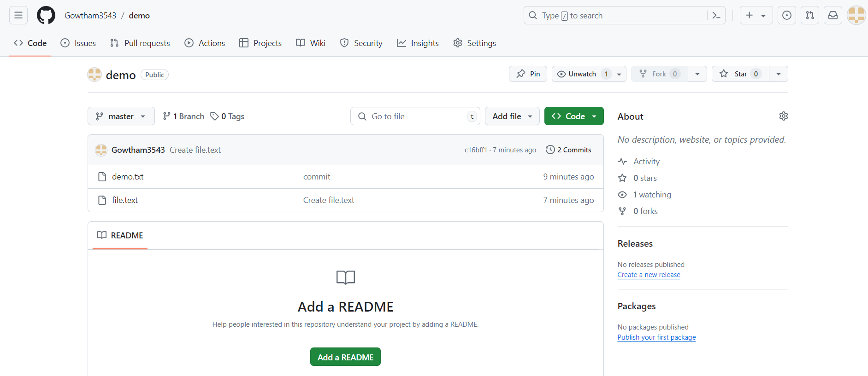

**git fetch**: Downloads changes from a remote repository but does not merge them into the local branch.

**git pull**: Downloads changes from a remote repository and immediately attempts to merge them into the current branch.

I have fetched file and saw what changes as made before I merge to local repo so we use fetch (you see that file.text is not in local but we can see what changes are there)

Whereas pull will not allow you to see what changes made it will immediately merge

**git fetch origin**

We use below command to see changes

**git diff origin/master**

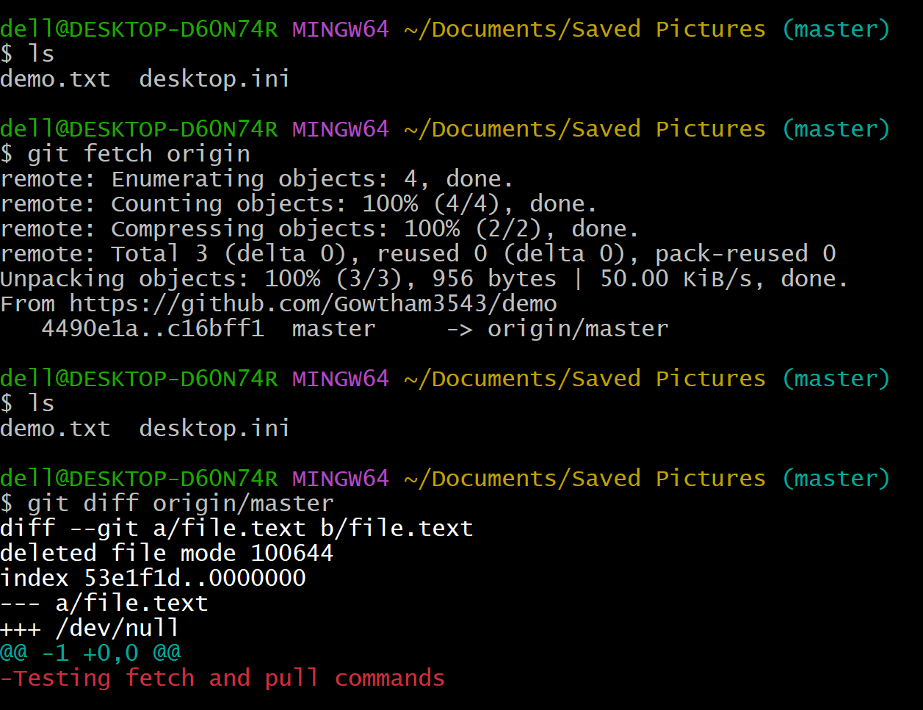

**git pull origin**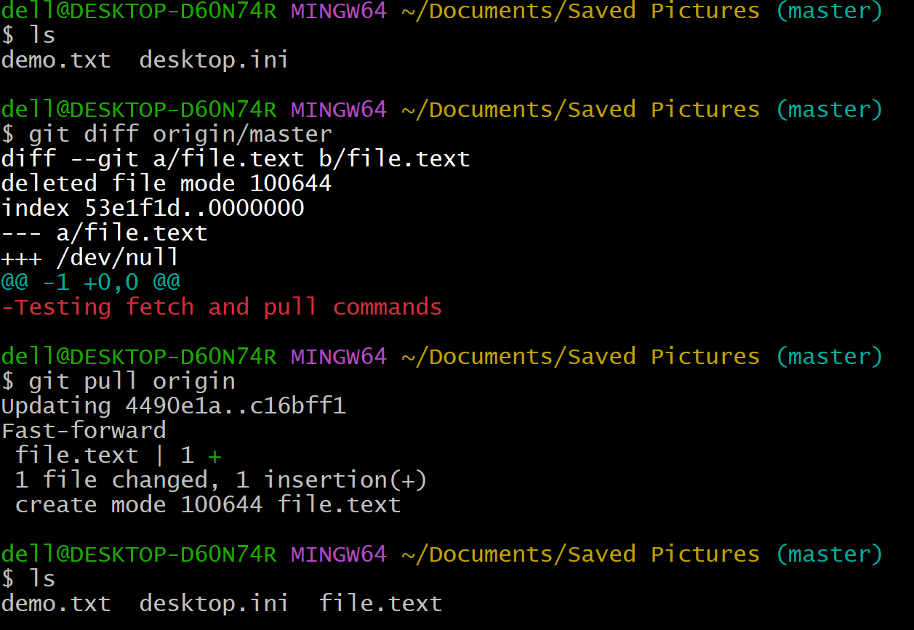

**Here we can clearly see the differnece beteween fetch and pull commands.**